

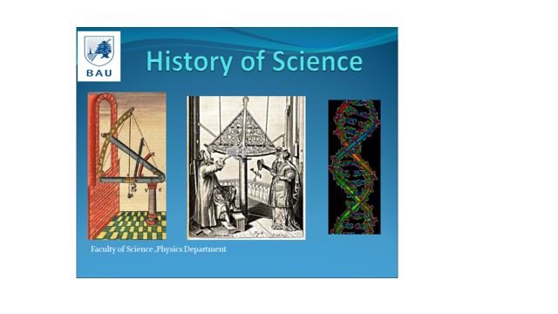

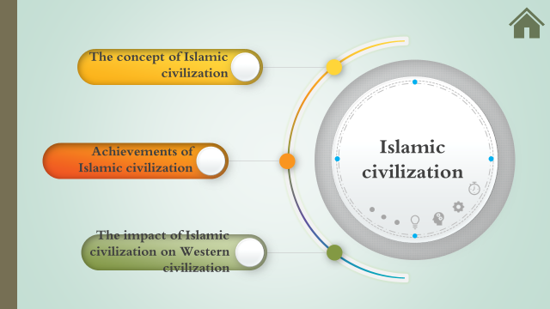

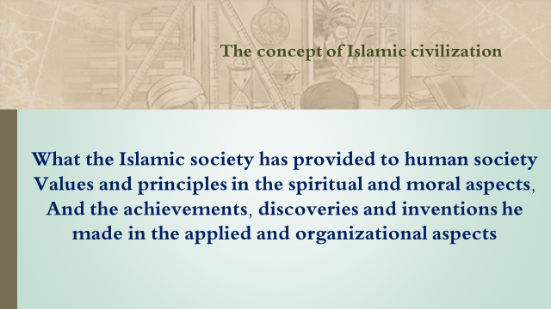

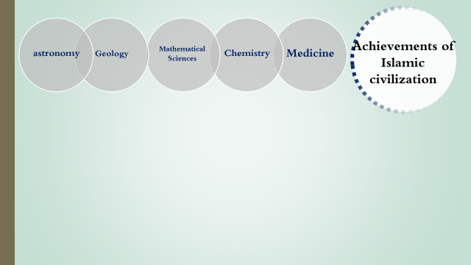

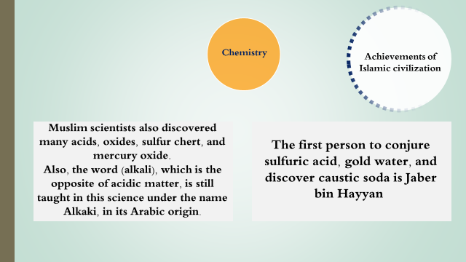

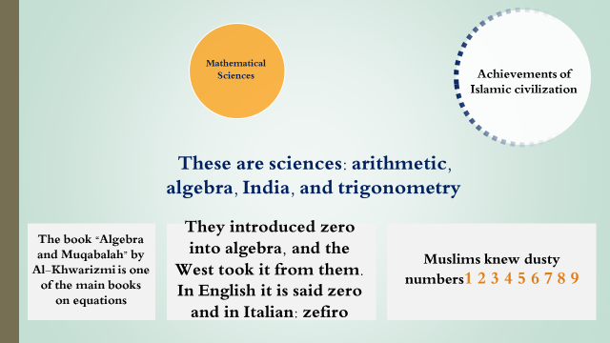

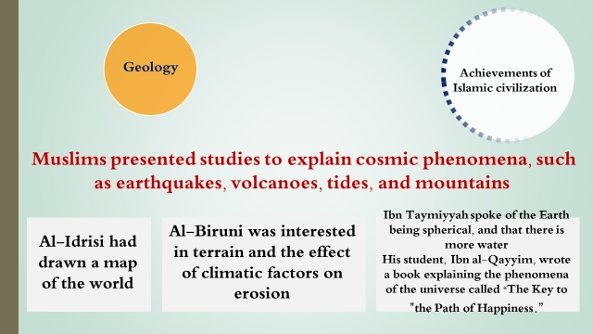

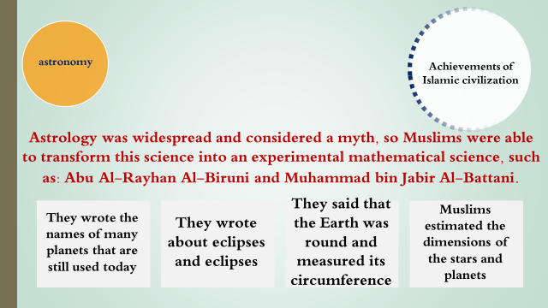

**the history of Greek civilization**

Greek civilization (in English: Greek Civilization) is defined as the period that followed the Mycenaean civilization, which extended from 1200 BC to 223 BC and ended with the death of Alexander the Great. The period of Greek civilization was characterized by many achievements in various scientific, artistic, and political fields, and philosophy, which left a distinctive legacy for Western civilization. 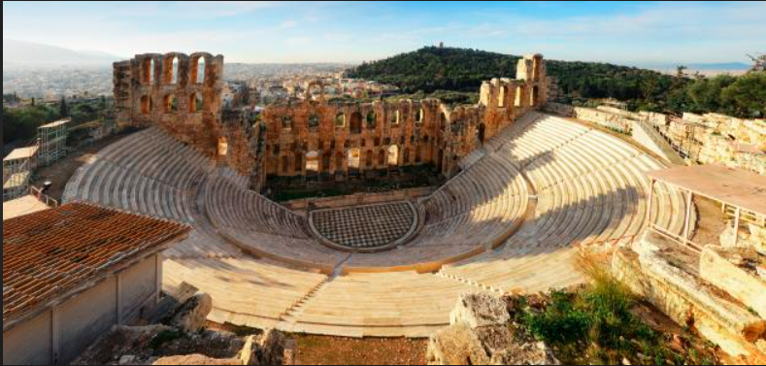

Achievements of Greek civilization

Philosophy

You will find the most famous philosophers in the world from Greece, especially since the Greeks were among the people most interested in searching for and pursuing knowledge.

They called the search for knowledge philosophy or the love of wisdom. Greek or Greek civilization included many famous philosophers such as:

Philosopher Socrates.

Philosopher Plato.

Philosopher Aristotle.

Nowadays, we rely on the philosophical theories left to us by the Greek philosophers, which are taught in various educational bodies as they have enabled us to understand the world.

.

Medicine

The achievements of Greek civilization are devoid of distinctive contributions in the field of medicine, and this is due to the ancient Greeks’ keen interest in the biology of living organisms.

The father of modern medicine, Hippocrates, was a resident of that civilization who left us many works and writings in the field of medicine and who diagnosed many diseases in a systematic and experimental way.

Among the most important achievements of the Greek civilization in medicine is that it contributed to leaving us with the first scientific reference on medical ethics in the Western world.

It was written by Hippocrates, in which he addressed the appropriate conduct, responsibilities, and duties that doctors must follow, as well as the most important ethical concerns that doctors may face.

Mesopotamia Civilization

The term Mesopotamia (Mesopotamia) refers to the historical geographical region located in southwest Asia, in which the first civilizations in the world arose. (Mesopotamia) in Greek means “between the rivers,” in reference to the region being located between two rivers. The Tigris and Euphrates, and Mesopotamia was considered the center of a culture whose influence extended throughout the Middle East, reaching as far as the Indus Valley, Egypt, and the Mediterranean region

**• First, the history of civilization**

* 

**Where did you grow up**

The beginning of development: Man settled in the Mesopotamian region for the first time in the Paleolithic Age, and by the year 14,000 BC, the inhabitants of the region lived in circular houses built in small settlements, and after five thousand years, the settlements developed into agricultural communities thanks to the development of agricultural methods. Irrigation and animal domestication.

Spread: Scattered agricultural communities developed in the northern part of the Mesopotamian region, then spread south and continued to grow for thousands of years until they finally turned into major cities in which the population was concentrated, and in which architecture and social and economic stratification developed.

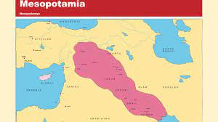

* The final geographical spot: The Mesopotamian civilization was centered in the eastern Mediterranean region, and was bordered to the northeast by the Zagros Mountains, and to the southeast by the Arabian Peninsula. The countries through which the Mesopotamian civilization was spreading today include Iraq and parts of Iran, Syria, and Turkey

**• Second: Achievements in Mesopotamia**

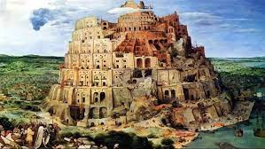

There are many achievements of these powerful civilizations that arose in this place, including:

1. The establishment of the most powerful states that were governed by an inherited monarchy in the cities of Mesopotamia. These civilizations had an organized system of government that expresses these organized and sophisticated civilizations at this time, where the rule was ruled by the king who ruled the country with the help of a number of officials who Each one chooses them according to his specialty.

2. Society also had a way of dividing it into classes: the ruling class, the free class, and the slave class.

3. There are many achievements added by the people of Mesopotamia, as they were proficient in arithmetic, geometry, and trigonometry, and this is what we see clearly in the way they built ziggurats, towers, and temples, and used bricks in construction.

4. The people of Mesopotamia also contributed to law and legislation, as they established the first laws and legislation in the world, as we see in the famous Code of Hammurabi, which contained some civil and criminal legislation and personal status legislation.

5. They contributed to creating their own calendar, which is considered one of the oldest calendars in the world, as they divided the year into months, days, and hours, and divided the year into two seasons, summer and winter.

6. They contributed to many inventions, the most important of which is the wheel.

7. They contributed to the field of medicine, as they excelled in the science of medicine and diagnosis.

8. They contributed to astronomy and geography, and learned about many planets, the colors of these planets, and the distances that separate them, in addition to their discovery of the phenomenon of eclipses and solar eclipses.

9. They contributed to the invention of weights, lengths, and measures.

10. The people of Mesopotamia contributed to the most important invention in humanity, which is writing. For the first time in history, they were able to use writing. They used cuneiform writing and wrote it on clay tablets using a special pen.

11. The inhabitants of Mesopotamia left a rich literary heritage such as mythological stories, epics, literature, and wisdom, such as the famous Epic of Gilgamesh.

12. The people of Mesopotamia contributed to agriculture and created irrigation canals. They added a lot to agriculture. They produced an abundance of agricultural production due to the Tigris and Euphrates rivers. They created one of the Seven Wonders of the Ancient World.

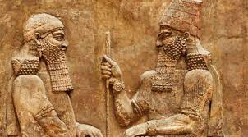

**• Other information about Mesopotamian**

The most famous cities of civilization

Among the most important cities: Uruk: Uruk is located in southern Mesopotamia along the banks of the Euphrates River. It was the center of Sumerian civilization. Uruk reached its peak around the year 2900 BC, and its population was estimated at about 80,000.

The modern era

Life science

The 19th century witnessed progress in life sciences through the study of microorganisms, especially after the French scientist Louis Pasteur achieved his revolution in preventive medicine in 1880 AD when he showed that some diseases are caused by germs and created protective vaccines against them for the first time in history, especially against rabies. He invented the method of pasteurization to prevent the spread of germs in milk and sterilize foods to prevent them from spoiling and transmitting infectious germs. In 1866 AD, the Austrian monk Gregor Mendel discovered genetics. The English scientist Charles Darwin followed him with his discovery of the theory of evolution, when he published his book The Origin of Species

The year 1859 AD. AD and in it he explained the theory of natural selection of species. And that humans have ape-like ancestors. They have evolved through biological processes. His theory was met with strong religious opposition, but scientists accepted it and acknowledged that evolution had actually occurred, despite some denying the mechanism of evolution. In the twentieth century, modern science appeared, with amazing scientific discoveries and achievements, especially in the fields of genetics, medicine, and social sciences. At the beginning of this century, biology entered a period of rapid development in genetic engineering, as Mendel's theory was rediscovered in 1900 AD. Following it, biologists became convinced of the existence of hereditary genes in the chromosomes of living cells. Which are threads containing proteins and nucleic acid (DNA molecule). In 1940 AD, he discovered that DNA taken from bacteria could change the genetic characteristics of other bacteria. He knew that DNA is the chemical compound that makes genes and is the key to heredity. After the American scientists James Watson and the British Francis Crick established a structure for a DNA molecule in 1953 AD. After that, genetic engineering made it possible to understand heredity through chemical concepts. He developed the genome, which is the genetic map through which biologists learned about human genes and their role in human life and diseases. This made identifying the genes that cause diseases a means of treating them through genetics. Transferring it from one organism to another to change some of its genetic characteristics and carry out the process of genetic hybridization

**Medicine**

In medicine, the twentieth century witnessed unprecedented development and major discoveries. The Dutch doctor Christian Eijkman discovered that diseases are not caused only by germs and cannot be caused by a deficiency of certain substances in food. So scientists came up with vitamins. In 1909, the German bacteriologist Paulus Ehrlich discovered the first chemical (sulfanilamide) that kills germs without killing the patient's cells. Then, in 1928 AD, British bacteriologist Alexander Fleming discovered the antibiotic penicillin. Then it was followed by other antibiotics, which kill bacteria and have no effect on killing viruses, which are still fighting their deadly viral diseases with serums and biological grafts until now. As in smallpox and polio, which almost disappeared from the global health map in the late twentieth century. Scientists expected the possibility of eliminating or controlling epidemics in 1980. However, they were shocked by the emergence of new strains of infectious germs resistant to antibiotics, such as tuberculosis (TB) germs and viruses that cause hemorrhagic fever or immunodeficiency such as AIDS. In the field of disease diagnosis, medicine has witnessed a boom in diagnostic imaging technology, such as magnetic resonance imaging and CT scanning.

